Instructions – Inserting a Link
Linking to another page in the website:
- Log in to your website with the administrator user.
- Go to the page you want to link to (not from). Once on the page, hover over the edit button – (do not click on it). When you hover over it, in the bottom left corner you will see the page address. On the end of this address there will be an extension /node/number. Ie domainname.com.au/node/29/edit.
Write down the ‘node/29’ part.
Note: The number at the end of the node is different for every page. If there is no node, write down the name of the page seen in the left hand bottom corner.
- Once you have the address information, go to the page that you would like to put a link on and select ‘Edit’.

- Once in editing mode, highlight the text that you wish to link to the page you collected information from before. Click on the ‘Insert/Edit Link’ button.

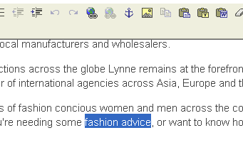

- Once you click on the button, a popup box will appear.
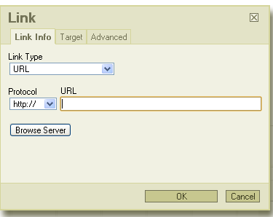
- In the URL field, insert the webpage information you gathered before (ie /node/29)
Note: The / must go before node and after it as well.

- The protocol will change from http:// to <other> if you type /node/number in. Do not change this.
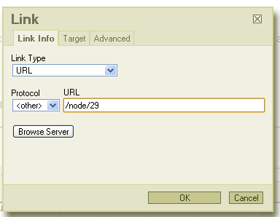
- Once you have typed in the correct information, click ‘Ok’
- The window will close and take you back to the editing area. You will notice that the highlighted text now is underlined and changes colour when you hover over it. The link has now been put in place.

- Scroll down to the bottom and click ‘Save’
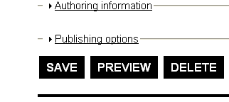

Linking to a page to another website:
- Select a website that you want your page to link to. Copy or write the address down.
- Log in to your website as the administrator and go to the page you wish to create a link on.
- Click the ‘Edit’ option.
- Highlight the text you wish to link to the other website and click on the ‘Insert/Edit Link’ button
- A popup will appear allowing you to create/change link properties

- In the URL section, paste or enter the URL of the website you want to link to. DO NOT CLICK ‘Ok’. After inserting the URL, click the ‘Target’ tab at the top.
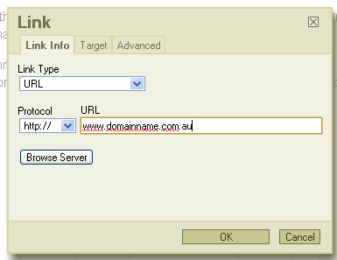
- This will change the options that you see on screen. Under the ‘Target’ drop down menu, select ‘New Window(_blank)’. This will ensure that customers are not taken off your site if they click the link as it will open in a new window. Do not change the ‘Target Frame Name’ field
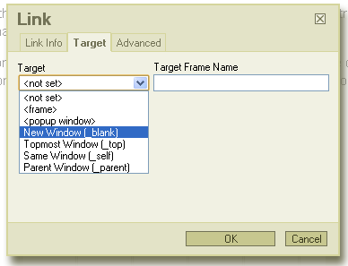
- Once that has been set, click ‘Ok’. This will close the popup thus returning you back to the editing page. The highlighted text will now be underlined, linking to the website you selected.
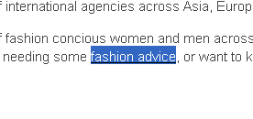
- Scroll down to the bottom and click ‘Save’
Removing a link:
- Login as administrator.
- Go to the page that the link you want to remove is on
- Select the ‘Edit’ tab to enter editing mode.
- Highlight the linked content
- Right click on the highlighted link, select ‘Remove Link’
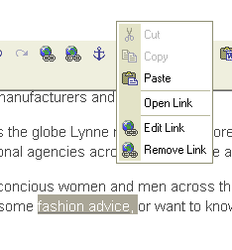
The link will now no longer be there


- Scroll down to the bottom and click ‘Save’

