Instructions – Editing Existing Content
There are a few ways that you can edit content on your Drupal website with the first being the easiest.
For pages with edit buttons:
- Login to your website using your administrator user login details.
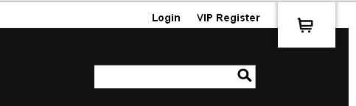

- Once logged in, go to the page you wish to edit. Once there, you should see a tab that says ‘Edit’.

- Click on ‘Edit’ and you’ll see field areas and the WYSIWYG editor.
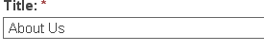
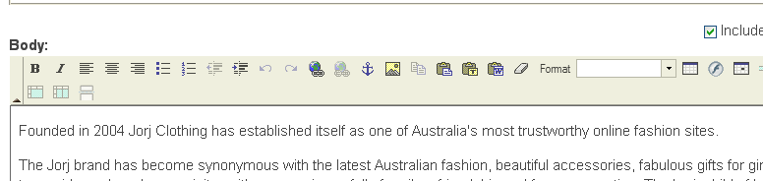

- Make any changes to the content that you require.
ATTENTION! If you are copying content from Word, PDF’s, a website or anywhere else, PASTE IT INTO NOTEPAD FIRST, then copy it from there and post it into the WYSIWYG editor.
Failure to do so can cause problems with the style and formatting of the content.
- After making your changes, scroll down to the bottom of the page where you will see ‘Save’, ‘Preview’ and ‘Delete’. You can delete the page here if you do not need it anymore. You can also preview the page before saving the content.
Note: If you do not want to delete the page (in case you may use it again later), there is an option on some sites to un-publish the page. This means that the public cannot see the page at all but it remains there in case you want to put it back up. This saves you from having to create the page all over again. This option is located under the heading ‘Publishing Options’. It is an expandable heading so users must click on it to see the options.
For pages without edit buttons:
- Login to your website using your administrator user login details.

- Go to the administration section and select ‘Content Management’
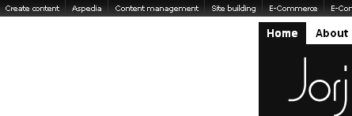

- Select ‘Content’
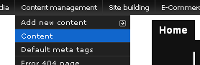

OR

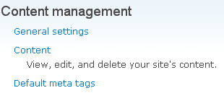
- Make sure you select ‘Find Content’ on the left hand side.
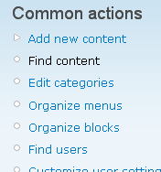

- There may be a long list of content that you have on your website, if this is the case, use the filter option above the list.
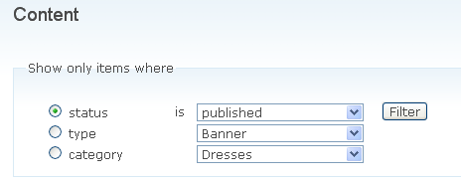
You can filter by ‘Status’, ‘Type’ or ‘Category’.
- Once you have located the content you wish to change, next to the name should be an ‘Edit’ button. Select that
- The ‘Edit’ option should take you to a page with the WYSIWYG editor and field areas.
- Follow from step 4 onwards from the ‘For pages with edit buttons’ section.
Note: If you go back to the content list, you will need to ‘Reset’ the filter so all content is shown in the list again.
