Instructions - Creating a Page
There may come a time where you need to add a new page for new content. This can easily be done in Drupal.
- First, log in to your website as the administrator.
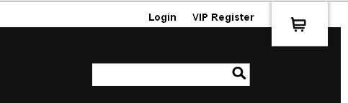

- Now in the administrator section, select ‘Create Content’. You will see the option ‘Page’. Select that.
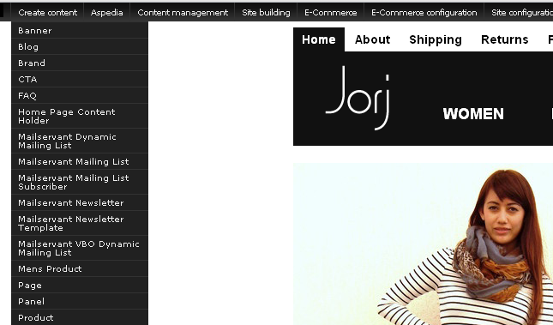
- Once you have selected ‘Page’ you will be taken to a different page where you can create a new one.
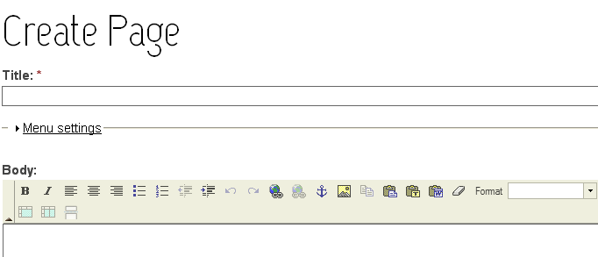
- From here you can create a title, create a menu link, enter content (ie images, text), enter meta tags and so on.
- Once you have set up the page, you can preview and save.
Creating a menu link for your new page:
- When creating your page, it’s best to have a link to it so users can access it. In order to create a menu link, you’ll need to edit the ‘Menu Settings’ which is located underneath the title.
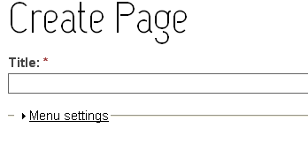
- Click on ‘Menu Settings’. It should expand and show you the options you can edit.
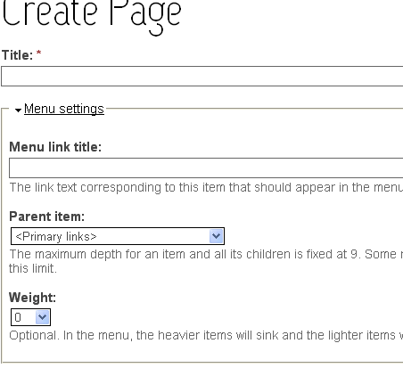

- In the ‘Menu link title’ field, input the name you want your link to have. (This will show in the menu).
- Once you have named it, select ‘Parent Item’. This should be a drop down menu with all of the main pages and the sub pages related to them. Select a page that you would like this page to relate to.
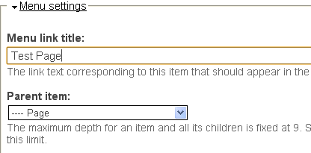
Note: ‘Weight’ is optional. In the menu, the heavier items will sink where as the lighter ones will be closer to the top of the menu.
You can also edit the publishing options for this page. You can make it so none of the public can see it but it exists. You can view all unpublished content by selecting ‘Content Management’, ‘Content’ and then on the left hand side in the menu ‘Find Content’. Use the filter ‘Status’ and select ‘Unpublished’. This will show ALL unpublished content on your website. From here you can select ‘Edit’ and then change the content to ‘Published’.
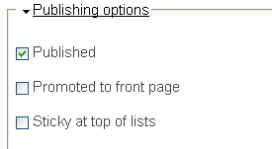
- When all editing has been completed, scroll down to the bottom and select ‘Save’.

