Instructions – Creating and setting up a new webform
This is an in-depth guide to help you create and edit webforms.
1. Log into your website under the 'webmaster' account.
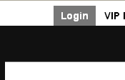
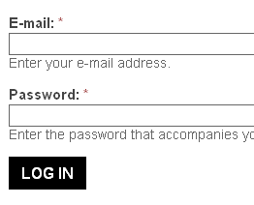
2. Once logged in, select 'Create Content' from the black toolbar at the top, followed by 'Webform'.

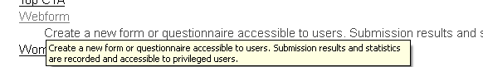
3. You will see a page that has a few fields for you to fill out. Give your form a title, add a bit of a description and fill out any other fields that are required.
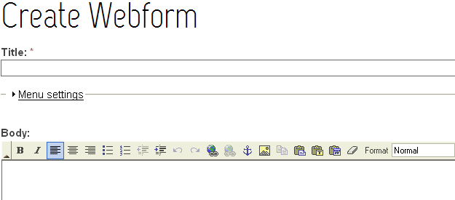

4. Scroll down to the bottom and select ‘Save’.

5. After saving, the page will present a 'Webform' section where you create the fields to go on the form. Create the appropriate fields for your form. Note: You will be required to fill in more information with each field you create.
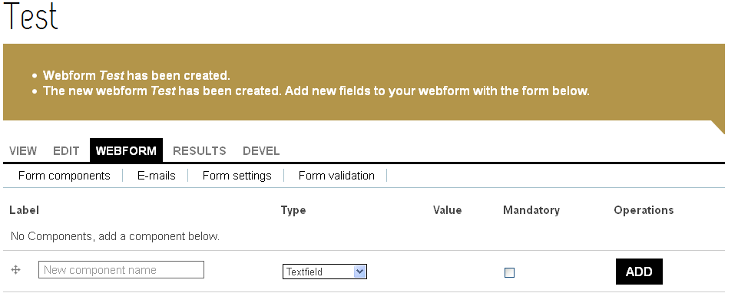
To create a field, fill in the component name, select the type and tick whether it is mandatory or not (users will not be able to submit form unless that field has been filled in).
6. Underneath the highlighted tab 'Webform', there is a sub toolbar. Within this toolbar, you can adjust the settings of this form. Such settings include what email address this form is sent to once it has been submitted. By selecting the 'Emails' sub tab, you will be presented with a page that will allow you to enter an email address to send the form to. Once an email has been entered, select 'Add'.
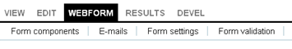
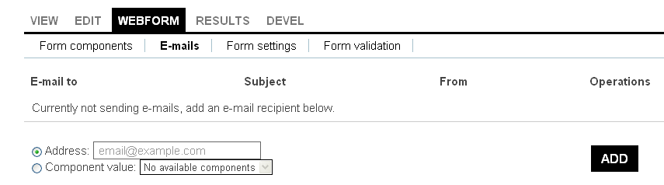

7. You will be taken to a page with more settings, if you wish, you can change them. It is recommended that you leave these settings as the default and scroll down to the bottom and click 'Save E-mail Settings'.
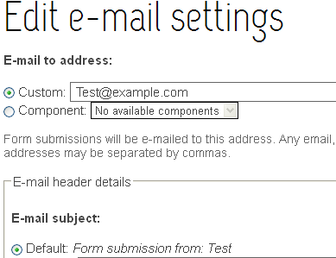

8. Next select the sub tab 'Form Settings'. This will take you to a page that allows you to create a confirmation message that lets your users know the form has been submitted successfully. After typing up a message, scroll down to the bottom and select 'Save Configuration'.
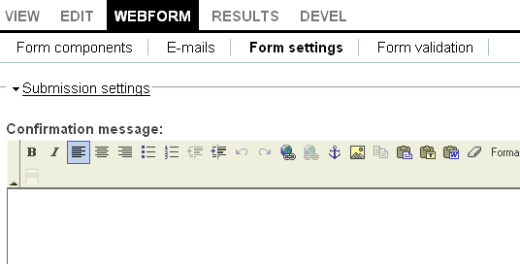
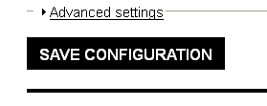

9. Go back to the 'Form Components' sub tab and click 'Save'.
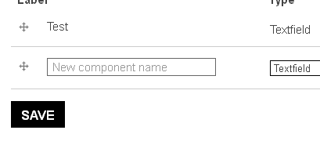

You have now set up a new webform
Editing a form
1. To edit a form, make sure you are logged in.
2. Select 'Content Management' from the black toolbar at the top.

3. On the left hand side there is a menu. In that menu, you will see an action ‘Find Content’. Select this
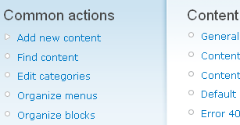
4. This will take you to a page where you can search for specific content on your site.
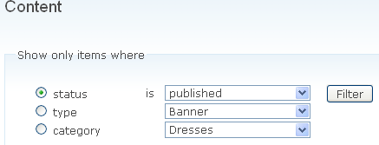

Select ‘Type’ and from the drop down menu select ‘Webform’
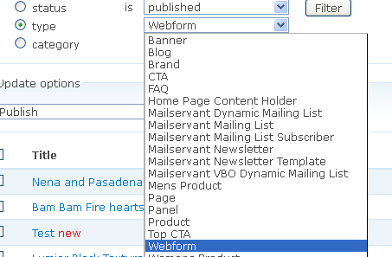
5. Select ‘Filter’. Once the page has loaded, you should see all webforms on your site. Select the one you wish to edit.
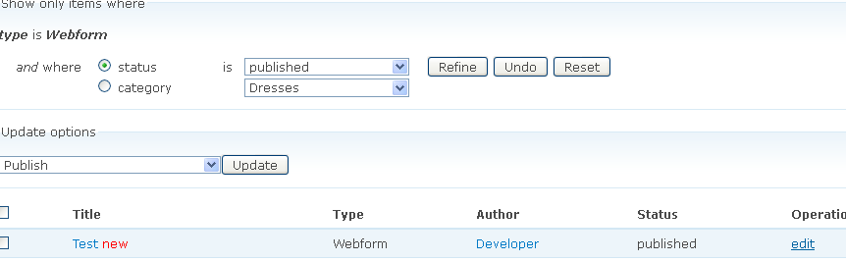
6. Make the changes you wish to make.
7. Select 'Save'.

