Instructions – eCommerce Section
If you have an eCommerce website, then you will have the option of viewing and managing transactions made through your website.
To do this, you must first be logged in to your account on your website. Once logged in, you will see a black tool bar at the top of the page.
To access all of the transactions that has taken part on your site, select the ‘E-Commerce’, then ‘Transactions’, followed by ‘Transactions List’. This will take you to a page that shows you all of the transactions (approved and pending).
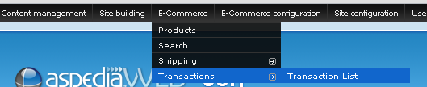
You will see a page similar to the following:
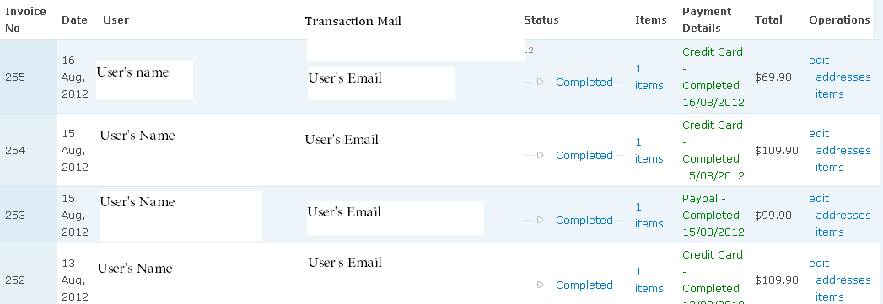
Please note: We have whitened the User’s name and email for security reasons. You will actually see their name and email address on your on site.
Explaining the screen caption:
Under ‘Payment Details’, anything in Green means the payment has been processed successfully. If you see ‘Red’ it means that the payment is still pending.
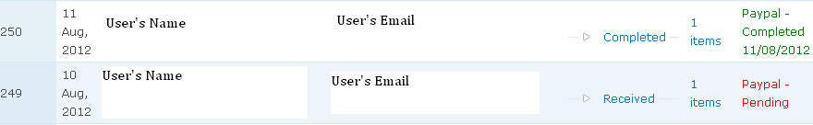

By clicking on the status (Completed/Received) you are presented with a list of options.
Print invoice: Allows you to print out the invoice and/or view what has been purchased
Shipping Notify: Allows you to send a message from your company to the client notifying them that their order has been shipped. This message can be changed to suit your needs.
Ask Customer: Allows you to communicate with the customer about their order. This is ideal for asking questions such as ‘What size are you in shirts?’ etc. They can then respond to you with the information you need to complete the order.
Cancel Transaction: Updates the status of the order to ‘Cancelled’.
Resend Invoice: This option resends the invoice to both yourself and the client.

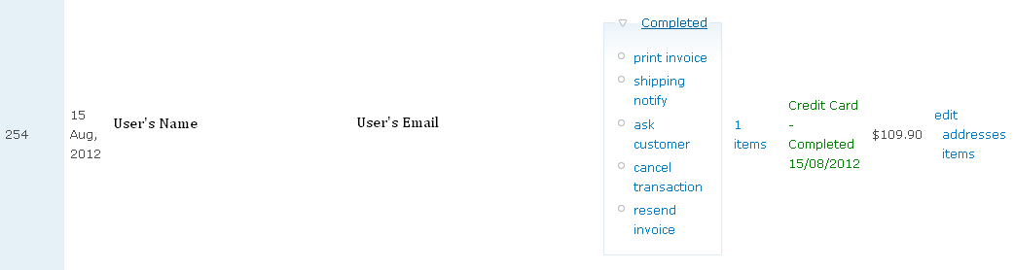
When you look at the options for an order with the status of ‘Received’, you have another option titled ‘Make Payment’.
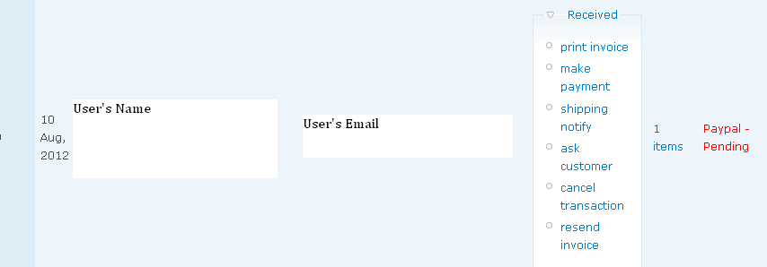
This option allows you to manually put a payment through so say, if you took a phone call and your customer gave you their credit card details, you could click on this option to enter their credit card details to charge them.
You can update the status of the order by selecting the ‘Edit’ option on the right hand side of the transaction information.
Here you will be able to change the status so that everyone understands what part of the payment process this customer is up to. It doesn’t do or change anything it’s just more of a notification system. This is the place you will need to go to update an order that was paid for over the phone. You can do this by scrolling down to the ‘Payment Status’ section and by selecting an option from the drop down menu.
